Wood Preservation Canada
Request for Proposal (RFP)
TRD Auditing Services for CWPCA Program
Date Issued: 01/08/2025
Proposal Due Date: 01/29/2025

1. Introduction
Wood Preservation Canada (WPC) invites proposals from qualified professionals to provide bilingual (English and French) auditing services for the Canadian Wood Preservation Certification Authority (CWPCA) Program, beginning Spring 2025 cycle.
The selected auditors will be responsible for ensuring that all certified wood treatment facilities across Canada comply with the standards outlined in Environment Canada's Technical Recommendation Documents (TRD). This includes verifying that facilities operate in an environmentally responsible manner and adhere to best practices in design, operation, workers’ safety.
Qualified proponents must demonstrate expertise in environmental compliance, operational auditing, and knowledge of wood preservation standards (CSA O80). Proposals should outline the candidate's qualifications, methodology, and approach to ensuring the integrity of the certification process; as well as history working with the pressure treated wood industry.
2. Certification Scoring Summary
The table below outlines the scoring summary objectives for the CWPCA Program for pesticides listed as part of the Canadian Environmental Protection Act (CEPA) and those that are not (non-CEPA).
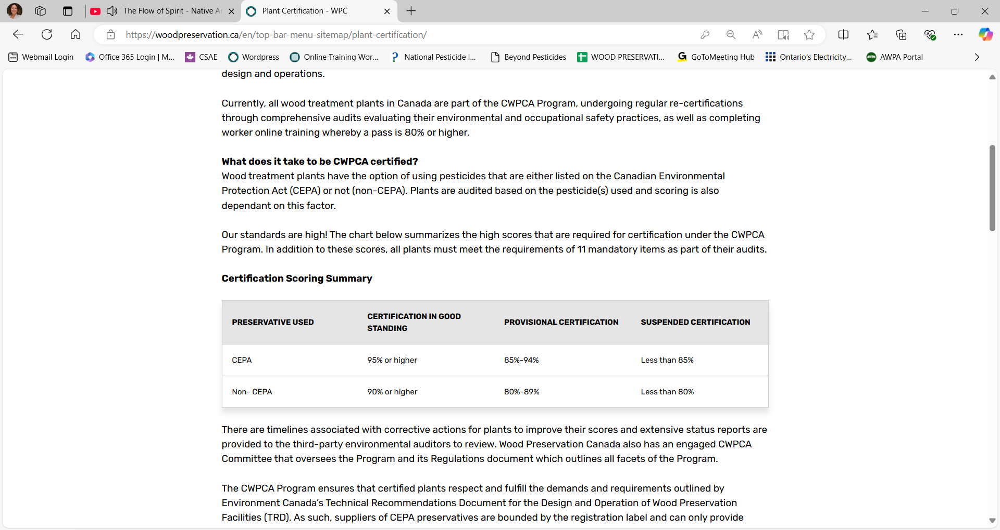3. Scope of Work
The selected auditors will complete annual internal audit reviews, and external audits every 3-years, during a three-year audit cycle for the 53 pressure treatment wood plants throughout Canada. These services must be available in English and French.
The selected auditors will work closely with WPC and the CWPCA Committee on all matters related to the CWPCA Program (worksheet updates, Regulations updates, appeals, re-audits).
4. Costs
Indicate the costs associated with each component of the CWPCA Program for the given 3-year proposal period:
Proposed External Audit Costs
# Cylinders | Audit Score > 95% | Audit Score 90 – 95% | Audit Score < 90%
1
2
3
4
5
Indicate any additional costs associated with facilities that use more than one pesticide.
Timing
Indicate, on average, how long (in days) an external audit will take.

Re-audits
Indicate the hourly cost associated with re-audits.
Additional Costs
Indicate the hourly cost association with additional work such as internal auditor reviewing, program revisions (worksheets and Regulations), virtual and in-person meetings.
Internal Auditor Training
Indicate the hourly cost associated with internal auditor training.
5. Proposal Requirements
Include the following information as part of the proposal:
- Company background and relevant experience
- Proposed approach and methodology
- Number of auditors that will be assigned to the CWPCA Program
- Proof of liability insurance
- Clearance letter from Workers’ Compensation Boards for Canada
- Timeline and key milestones
- Costs breakdown
- References

6. Submission Instructions
Proposal can be submitted:
- Submission Deadline: January 29, 2025
- Submission Method: Mail proposals with subject line: TRD Auditing Services for CWPCA Program to:
  - Wood Preservation Canada
2420 Bank Street, Mailbox #141
Ottawa, ON
K1V 8S1
- Information Package: To receive an information package (CWPCA Regulations, CWPCA Background Document, Technical Recommendations Document), please contact: Natalie Tarini, natalie@woodpreservation.ca, 613-737-4337

To learn more about the CWPCA Program, please visit woodpreservation.ca.

